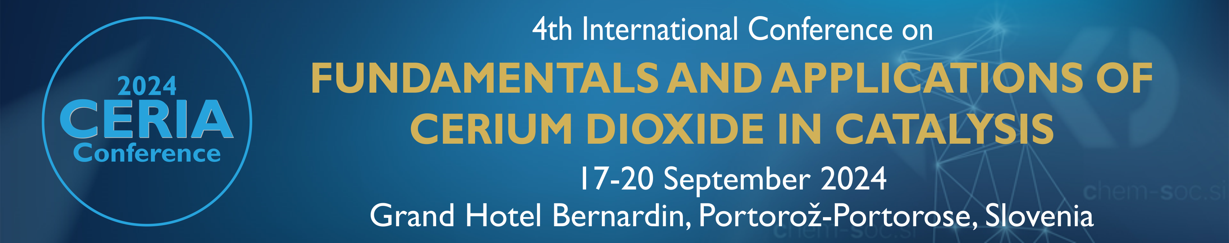

A C C O M M O D A T I O N F O R M

to be returned before 16 August 2024 to St. Bernardin Adriatic Resort & Convention Center, Obala 2,
SI-6320 Portorož-Portorose, Slovenia. Fax: +386 5 690 70 10; E-mail: booking@sava.si

GUEST DETAILS (COMPLETE IN BLOCK CAPITALS)

Family name: |  |  | First name: |  | Title:
_______________________________ |  |  | _______________________________ |  | _______
University/Institute/Company:
___________________________________________________________________________
Address:
___________________________________________________________________________
City: |  | Zipcode: |  | Country:
_________________________ |  | ____________________ |  | ________________________
Phone: | Fax: |  |  | E-mail address:
________________________ | _______________________ |  |  | ________________________

CONFERENCE Room rates

Hotel | Single use of a double room | Double room
Grand Hotel Bernardin***** | 172 € | 192 €
Hotel Histrion**** | 162 € | 182 €
Hotel Vile Park*** Premium | 132 € | 142 €
The above prices are per room per night and include buffet breakfast, free Wi-Fi access, entrance to the renovated Water Park Termaris – Hotel Histrion (for guests of GH Bernardin 5*: entrance to the pool and fitness Spa Paradise), free parking, and VAT. Tourist tax (2.50 € per person per night) and booking fee (1.00 € per person per stay) are charged extra.

Please indicate your choice of preferred hotel and the type of room required:

❑ Grand Hotel Bernardin***** | ❑ Hotel Histrion**** | ❑ Hotel Vile Park*** Premium

❑ Double room | ❑ Single use of a double room

Date of arrival: ______________________ Date of departure: ______________________

Sharing a room with delegate: ________________________________________________
(Please write the name and family name of the delegate sharing a double room. If sharing with another delegate, it is important for only one person to make the room reservation on their accommodation form, and send only one deposit.)

GUARANTEED RESERVATIONS

Accommodation at the conference rates listed above will be guaranteed only to those who will have sent their request by 16 August 2024. All requests received after this date will be subject to availability. A guarantee of accommodation is required to confirm your booking. To guarantee your booking, choose one of the options below:

❑ Guarantee by credit card
To reserve a room with a credit card payment, please call (+386 5 690 70 00) or send this form (with filled-in data below) by either fax (+386 5 690 70 10) or e-mail (booking@sava.si) to the hotel reservations department. If you prefer to call in your reservation, be sure to identify yourself as a »2024 Ceria Conference« attendee to obtain the conference room rates.

Credit card information | ❑ American Express | ❑ Visa
 | ❑ Eurocard/Mastercard | ❑ Diners

Card number: _________________________ | Verification number (3 or 4 digits): _____
Name of cardholder: ________________________________________________________
Expiry date: ______ / ______

Date: _______________________________ | Signature: ___________________________

❑ Guarantee by bank transfer deposit
After sending the completed accommodation form to the hotel reservations department, you will be provided with all details about the remittance of the deposit.

Cancellation policy

In the case of a guarantee with a credit card: if you cancel the reservation 72 hours before the arrival date - no costs. In case of late cancellation or non arrival, the hotel reserves the right to charge your credit card in the amount of a one-night stay.

In case of paid deposit: if you cancel the reservation 72 hours before the arrival date, the hotel will return you the amount of paid deposit reduced by 10 %. In case of late cancellation or non-arrival, the hotel reserves the right to keep the whole deposit.

The reservations department of St. Bernardin Adriatic Resort & Convention Center will be happy to confirm your reservation as soon as possible. For any information, please call (+386 5 690 70 00) or send an e-mail (booking@sava.si).

